Do’s and Don'ts of

Hardware Deployment

Loading and Unloading Equipment
- 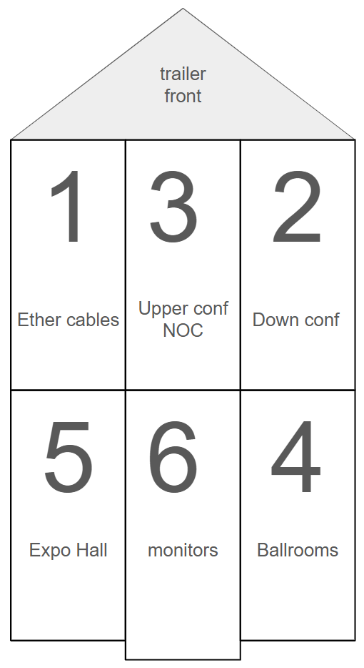

Gaffers tape vs. Duct Tape - Purpose of tape

Clean installation and removal protocol (Wire & Hardware)

Difference in Cables (Network wires, power cords, fiber optics)

How to wrap a wire

(VIDEOS AND PICTURES COMING SOON)

